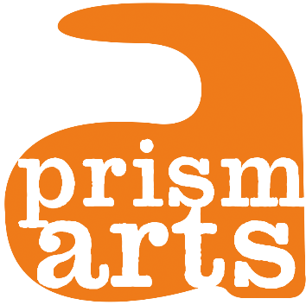

**Prism Arts**

**Performing Arts Lead Job Pack**

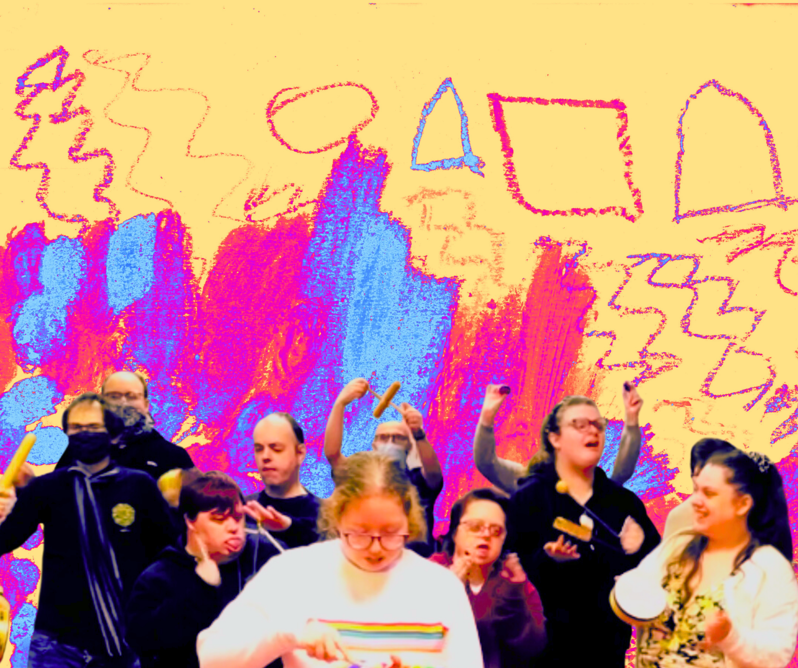

**About Prism Arts**

*Creating a World of Art Without Barriers*

**Who We Are**

Prism Arts (Registered Charity Number 1159797) is a leading inclusive-arts charity based in Carlisle in Cumbria that provides creative opportunities for more than 2,500 people with learning disabilities and / or autism (LDA) each year.

**We empower people with learning disabilities and / or autism to make excellent art, allowing them to drive their own creative journey as artists, leaders, and advocates for change.**

Founded in 1987 by a group of artists developing opportunities for excluded people, we work with individuals aged 14+, helping them to define their own goals and ambitions through a series of creative projects, leading to a growth in independence, confidence, and improved wellbeing.

**Our unique model allows participants to take charge of their own creative journey, giving them the freedom and space in a highly supportive environment to flourish as artists and individuals.**

**What We Do**

Our programmes are run by a small expert team, providing regular engagement opportunities with visual or performing arts, the creation of new work, and the development of new relationships. Everything we do is designed in response to the individual needs of our participants, with Personal Progress Plans and journey mapping exercises set-up and tracked for each artist:

* + 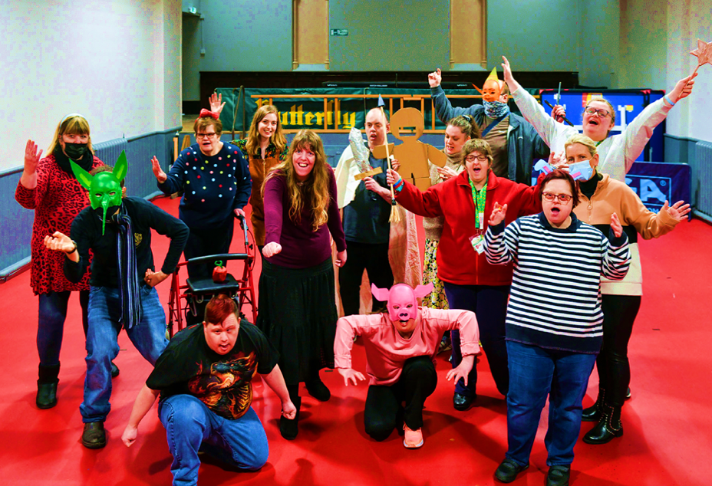**Our Studio Art** (<https://www.prismarts.org.uk/join-us/studio-arts/>) group supports 12 adults with learning disabilities to create visual art on a weekly basis. Focused on fine arts, participants work with professional artists to develop a range of skills, including print making, painting, clay work and textiles, which are then showcased in exhibitions around the county.

These sessions are designed in collaboration with our participants, giving each person the opportunity to direct their own creative development, make new friends, build confidence, develop skills, and gain independence.

* + **Our** **Studio Theatre** (<https://www.prismarts.org.uk/join-us/studio-theatre-carlisle/>) group convenes to develop performing arts skills, including producing and performing new work to the local community. Across the sessions, 12 participants get the opportunity to sing, play music, develop audio and filmed work and then perform across venues and public spaces including Theatre by the Lake and Carlisle City Centre. Participants gain a huge range of benefits from the sessions, including talent development, team building and socialisation.

***“The great thing about Prism is that they focus on my son’s abilities & not his disabilities”***

Parent of a member of the Studio Theatre group

* + **Our Studio Focus** (<https://www.prismarts.org.uk/join-us/studio-focus/>) group brings together adults with LDA in a weekly programme of applied arts. Working with a skilled creative professional, participants who come to these sessions develop creative skills, learn to work independently, and platform their talents through public exhibitions across Cumbria.
  + **Our Projects** are designed and delivered in response to the needs of local people, cultural and heritage organisations, colleges, charities and community groups. In 2022, this included our Youth Arts Programme with the James Rennie School, supporting 10 young people (aged 16 – 19) with learning disabilities and / or autism to develop their creative skills and build their confidence. We also ran a new programme, Rest Under the Stars, which was commissioned by Carlisle Cathedral and enabled us to showcase the talents of our artists to over 2000 audiences.

**“Prism Arts has made Michael more confident to speak out and communicate with others in a group that he enjoys in a pleasant and rewarding atmosphere.”**

Mr & Mrs Shepherd, Parents of Prism Artist Michael

**As the only specialist disability arts organisation in Cumbria, we play a vital role in championing and promoting the creative work of people with disabilities across our region, giving them creative skills as well as boosting their confidence, independence, self-esteem and wellbeing.**

* In 2019/20 we widened our participation opportunities to disadvantaged groups, delivering 700 workshops, reaching 9,500 adults, and engaging 1,000 children aged 5 to 11 by working directly with schools.
* In 2021/22, whilst our work was affected by the Covid-19 pandemic, we were still able to deliver 515 workshops, developing the skills, confidence, and wellbeing of 2,802 participants. This included our new project, Picture of Me, which supported 30 disabled people through a series of workshops in response to the isolation caused by Covid-19, enabling them to produce high-quality work for local audiences, including street art, dances, film and an audio trail across West Cumbria.
* In 2021/22, we were also able to deliver four in-person performances; host two exhibitions in Cumbria, reaching an audience of over 9,338 people, and run a new project in partnership with University of Cumbria, enabling 10 emerging artists to develop progression pathways toward professional practice including the chance to work in specialist workshop spaces with technicians, collaborate with fine-art graduates and engage in formal learning routes.

***“My hope is that through events like these [a Prism Arts exhibition], Carlisle becomes a city that lives and breathes art that is enjoyed by and stimulates all of its people.”***

Pam Birks, Carlisle City Mayor

**Our Team and Partners**

Our work is led by a small expert team of just nine part-time staff, with Catherine Coulthard, Strategic Director, and Jane Dudman Creative Programme Director at the helm. This team punches well above its weight, with extensive experience in inclusive arts, creative programming, facilitation, finance, and marketing, and is supported by a skilled Board of Trustees bringing together expertise in inclusivity, the arts and charity sectors, strategy, and the local community.

Alongside this, our partnerships with bodies such as Arts Council England, Theatre by the Lake, Tullie House Museum and Art Gallery, University of Cumbria, and English Heritage, help us play a strategic role locally and nationally, whilst our representation on the boards of West Cumbria Creative People and Places, Carlisle Culture, Creative Minds’ North Network and LCEP West Cumbria and Carlisle, enables us to raise awareness of the importance of accessibility in the arts and advocate for our beneficiaries.

Our work is firmly rooted in our community in Carlisle, but increasingly we are looking to return to working in West Cumbria.

**We are looking for a committed and engaged Performing Arts**

**Lead to deliver and shape our performing arts programmes**.

**JOB DESCRIPTION**

**Job Title:** **Performing Arts Lead**

Our Performing Arts Lead is an integral role at Prism Arts leading on the development and delivery of our performing arts programme. This role suited to people who are passionate about inclusive arts practice and performing arts.

You would be joining Prism Arts at an exciting time helping as we evolve our performing arts offer by placing our participant artists at the centre of their own creative journey.

**This role will suit people looking to develop a career in inclusive performing arts practice as well as artists with a more established practice.**

**Job Purpose:** To manage the development and delivery of our performing arts programme, embedding excellence and progression of our participants throughout, from decision making to skills and practice development. To seek out opportunities to see and work with visiting artists and companies that extend the experience of our participant artists and open up opportunities to further develop their skills and creative progression.

**Start Date:** From August 2023, in advance of the new academic year starting Sept 2023.

**Hours:** (0.4) PRO RATA.15 hours per week. Friday is a core day; other days are flexible depending on programmed activities. As the charity grows, we anticipate hours of work will increase.

**Contract:** Permanent

**Location:** Core delivery sessions will be delivered on site at the Methodist Central Hall. We are supportive of hybrid and flexible working outside core delivery days.

**Salary:** **FTE** £25.5k - £27k PRO RATA, based on experience

**Reporting to:** Creative Programme Director

**Line managing:** No line Management responsibilities, other than managing Facilitator Artists in session and providing briefings/ workplans. This might change in the future.

**Training and development:** Full training will be given to support the candidate with a particular focus on desirable areas listed in the person spec.

**Employee benefits**: Health Shield, Birthday Leave, Bike Loan Scheme, Pension, 33 days Holiday entitlement (incl. bank holidays pro rata),

|  |
| --- |
| **Main Tasks and Responsibilities:**   * Develop an annual performing arts programme that sets out a plan for the year with a particular focus on our Studio Theatre programme, SEND schools and collaborating with artists to shape performing arts opportunities across all our programmes. * Deliver weekly workshops for our Studio Theatre artists, activity developing skills and creating new work. * Develop an end of year performance/ celebration (July/August) * Programme opportunities for Studio Theatre artists to perform and share their work and to see contemporary work and work with visiting artists/companies to support artist skills development and progression. * Engage with our partnership programme with Theatre by the Lake (NPO) and Access All Areas. * Work closely with the Lead Visual Artist to ensure collaborative working and an equality of opportunity across the studio programme. * Work with Communications Lead to support and broaden access to raise the profile of participant artists work and achievements. * Work closely with our Participant Support Leads to develop individual progression plans for our participants and adapt to their needs. * Manage participant support artists, staff and artists in your sessions. * Manage budgets relating to your delivery programme. * Support the development of project proposals and assist with the development of funding applications. * Lead debriefs after sessions ensuring information is recorded and shared when necessary * Work with the team and Creative Programme Director to evaluate your programme of work, to evidence artist progression and the impact. * Undertake internal and external reporting to funders, stakeholders, families, and individuals as required. * Assist in provision of publicity and marketing materials for your programme and projects, including digital and print marketing, social media and website. * Produce data on your activity for board and annual reports on a quarterly basis. Attend meetings if required. * Represent the charity in an appropriate manner at all times when dealing with partners, volunteers, suppliers, clients, customers, and colleagues. * Ensure effective communication is achieved at all levels and in particular at a team and individual level. * Undergo any necessary on-the-job training required to develop the skills and knowledge needed to be able to perform to the standard required. * Undertake any other duties that may be required by the organisation. |
|  |

**Person Specification**

**Essential**

* Passionate about working with people with learning disabilities and autism and the ability to create the right environment to support their development and encourage their creativity.
* Experience delivering performing arts workshops.
* Experience of a wide range of performing arts delivery methods and practices
* Experience of producing and developing work for production
* Ability to work from own initiative but also collaboratively as part of a team
* Excellent verbal and written communication skills
* Experience of evaluation and report writing

**Desirable**

* Knowledge of regional and national performing arts practice
* Experience of designing and delivering participatory performing arts programmes.
* Experience of working with people with learning disabilities and autism (we can support training to develop skills in this area)
* Working knowledge of Microsoft Office packages
* Experience of project management
* First Aid training
* Safeguarding training
* Budget management

**Equal Opportunities**

We are committed to becoming more inclusive and representative of the communities we serve.

We embed diversity as part of our belief that a better understanding of people’s differences helps us to appreciate and value everyone’s contribution and recognise that we are all an integral and invaluable part of our Society. Everyone has the right to be treated with consideration and respect.

Our organisation is committed to achieving a truly inclusive environment for all, by developing better working relationships that realise the individual’s full potential and creativity in an atmosphere where everyone can learn and work free from prejudice, discrimination, harassment and violence.  
We recruit artists and operational staff through our Equal Opportunities Policy and Diversity Statement. All disabled candidates reaching the minimum criteria for shortlisting will be invited to interview.

We will require the post holder to take part in a company wide access audit in the autumn of 2023 led by Birds of Paradise.

**How to Apply**

To apply for this post please complete the **application form below**, on that form there are details about how you can apply via voice/video recording instead of written word. If you would like apply another way or would like this information in another format, please get in touch, phone: 01228 587691 or email: [office@prismarts.org.uk](mailto:office@prismarts.org.uk)

We would also be grateful if you could fill in our **equal monitoring form below**.

[Application Form](https://forms.gle/q8f17SUv9HVDJcrG9)

[Equality Monitoring Form](https://forms.gle/rnY99tCAqEMkGoRd8)

If you would like an informal discussion about this position, please email Jane Dudman (Creative Programme Director) at [jane@prismarts.org.uk](mailto:jane@prismarts.org.uk)

Interviews will take place on **July 26th 2023**.

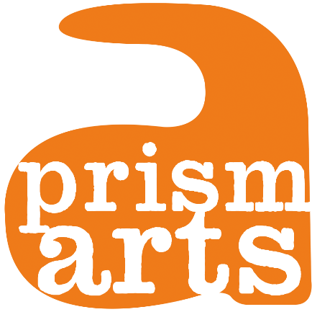

Learn more about Prism Arts and our work on our website:

www.prismarts.org.uk